BYD DOLPHIN Leaps into Europe
Bringing Innovation in Agile and Affordable High-Tech Electric Mobility
19 June 2023
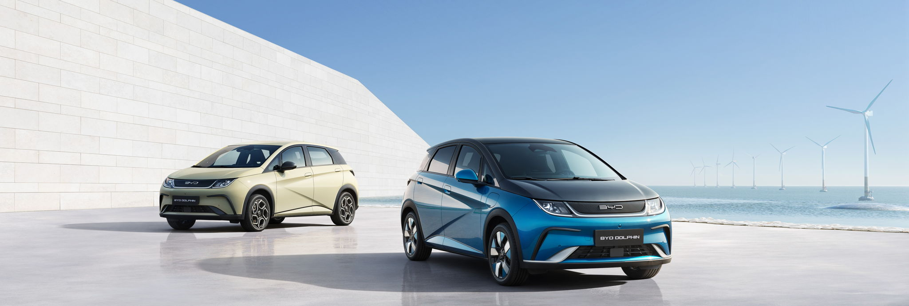
- The agile and versatile eco-friendly BYD DOLPHIN C-segment hatchback is officially launched in Europe with delivery from Q4 2023
- Pure-electric: Available with a highly efficient 60.4 kWh LFP Blade Battery with a 427 km range (WLTP) and later also with a 44.9 kWh LFP Blade Battery with the estimated range (WLTP) of 340 km for Active and 310 km for Boost
- High-tech electric mobility available and accessible for everyone with attractive pricing between €29,990 to €36,740
- BYD DOLPHIN makes practical and effective use of the state-of-the-art e-Platform 3.0
- High levels of standard equipment and driver technology feature across the BYD DOLPHIN range
- BYD DOLPHIN is offered in four trim levels (Active, Boost, Comfort, Design) and will be available in LHD and RHD markets

BYD, the world’s leading manufacturer of New Energy Vehicles (NEVs) and power batteries, announces the market launch of the new pure-electric BYD DOLPHIN in Europe. This all-new C-segment hatchback combines distinctive ‘playful’ design aesthetics with versatility, agility and an abundance of standard equipment, together with BYD’s game-changing EV technology. The epitome of safe, efficient and practical eco-friendly motoring, the BYD DOLPHIN is appealingly priced making high-tech electric mobility accessible to more consumers.Sales will commence in the summer of 2023 with deliveries across Europe starting in Q4 of 2023.

Introducing the Pure-Electric BYD DOLPHIN C-Segment Hatchback
The BYD DOLPHIN is the first model in the Ocean series and the first to adopt BYD’s “Ocean Aesthetics” design concept giving it a distinctive and stylish appearance. Influencing the car’s design is the dolphin; an intelligent, playful and friendly marine mammal, which is depicted in both figurative and imaginative forms. The DOLPHIN offers a 60.4 kWh – and later (from Q1 2024) also a 44.9 kWh - Lithium Iron Phosphate BYD Blade Battery, and benefits from an exclusive safety body structure for pure-electric vehicles. It also has a complete range of active and passive safety features, which gives it an incomparable advantage in terms of safety performance. The BYD DOLPHIN also features a safe passenger compartment environment, with intelligent driver assistance systems and integrated braking systems for safer travel and easier driving.

Revolutionary Blade Battery as Standard
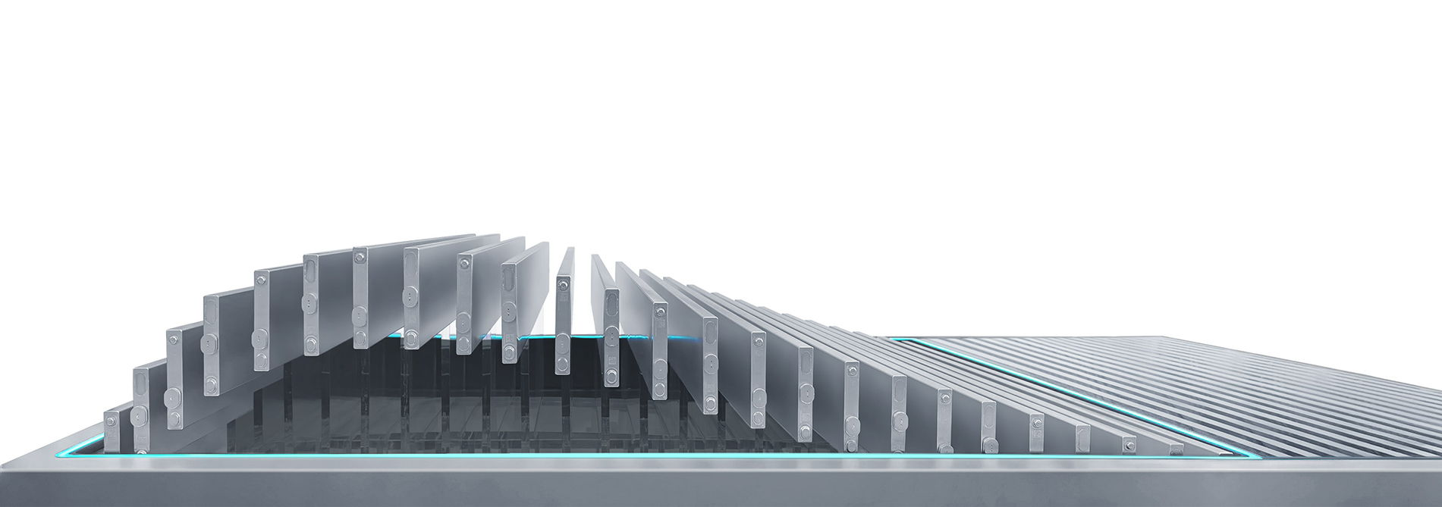
The BYD DOLPHIN benefits from the ground-breaking Blade Battery, which is revolutionising safety, durability and performance in the EV industry, and safely passed the Nail Penetration Test, regarded as the ‘Mount Everest’ of battery safety tests. BYD DOLPHIN’s cobalt-free Blade Batteries use Lithium Iron-Phosphate (LFP) as its cathode material, which offers a much higher level of safety than conventional lithium-ion batteries. LFP has inherently excellent thermal stability. While being ultra-safe and durable, the Blade Battery is uncompromising in performance, delivering high power density with the benefit of ultra-low energy consumption.

Electric Powertrain Technology for the Ultimate in Efficiency and Intelligence
The Blade Battery works in close synergy with BYD’s competency in electric powertrain technology. BYD DOLPHIN is, like the BYD ATTO 3, built on BYD’s intelligent e-Platform 3.0 for the ultimate in system efficiency and integrated vehicle intelligence. BYD’s 8-in-1 electric powertrain integrates the Vehicle Control Unit, the Battery Management System, the Power Distribution Unit, the Drive Motor, the Motor Controller, the Transmission, DC-DC, and On-Board Charger. Such deep integration delivers a system efficiency of 89%. This integrated technology has been developed to deliver optimum performance and a better driving experience.

BYD DOLPHIN Pricing Represents Excellent Value and Makes Electric Mobility Widely Accessible
“BYD is convinced that high-tech electric mobility should be available and accessible for everyone. Therefore, we ensured that BYD DOLPHIN is not only intelligent and technology advanced, but also attractively priced”, says Michael Shu, General Manager and Managing Director of BYD Europe and International Cooperation Division.
BYD DOLPHIN offers a choice of four different models: Active / Boost / Comfort / Design.
BYD DOLPHIN Active: 44.9 kWh battery combined with 70 kW (95 ps) motor. This version can be charged by AC power up to 7 kW and by DC power up to 60 kW. Price: 29,990 euros.
BYD DOLPHIN Boost: 44.9 kWh battery and 130 kW (176 ps) motor. Adds 17-inch wheels and multi-link rear suspension. Price: 31,740 euros.
BYD DOLPHIN Comfort: 60.4 kWh battery and 150 kW (204 ps) motor. Claims a range of 427 kilometers with a fuel consumption of 15.9 kWh/100 km. Maximum charging is 88 kW (from 30 to 80% in 29 minutes) but alternating charging reaches a maximum of 11 kW. Price: 35,240 euros.
BYD DOLPHIN Design: Same technical specifications as the Comfort, but also adds a panoramic roof, VtoL power strip, privacy glass in the rear seats and wireless smartphone charging. Price: 36,740 euros.

Acceleration and Performance
With the 60.4 kWh Blade Battery and a permanent magnet synchronous motor, the BYD DOLPHIN can accelerate from 0 to 100 km/h in just 7 seconds. The 310 Nm of torque and 150kW/204 PS strong motor provide seamless performance helping the Dolphin reach a maximum top speed of 160 km/h. The four driving modes include Sport, Normal, Economy, and Snow to suit driving different conditions and preferences.

Convenient Charging and Reassuring Range of 427 km WLTP
The BYD DOLPHIN with 60.4 kWh battery has a reassuring WLTP combined electric range of 427 km. Charging power is 11 kW AC 3 phase. High performance is also achieved when it comes to recharging. The 100 kW DC charger can replenish the battery from 30% to 80% in just 29 minutes. The BYD DOLPHIN is also equipped with VtoL (Vehicle to Load), so the car battery can easily charge external devices. The BYD DOLPHIN with the 44.9 kWh LFP Blade Battery has an estimated range (WLTP) of 340 km for Active and 310 km for Boost. Further technical details for these trims will be announced closer to the market entry which is to be expected in Q1 2024.

Highly Efficient Integrated Heat Pump as Standard
Efficiency is a key element for the BYD DOLPHIN. Therefore, a high-efficiency integrated heat pump is ​ standard. The industry’s first direct cooling and heating system for power batteries increases the thermal efficiency by up to 15% in the winter. This innovative system leverages the residual heat from the surroundings, the powertrain, the passenger compartment and even the batteries, and can work at a wide range of temperatures. Intelligent thermal management for extreme weather conditions enables an excellent low-temperature driving range. As a sub-function of the smart brake system, the CRBS coordinated regenerative braking system can efficiently recover the braking energy of the whole vehicle.

DOLPHIN Concept: Agile, Versatile with a Modern Welcoming Aura

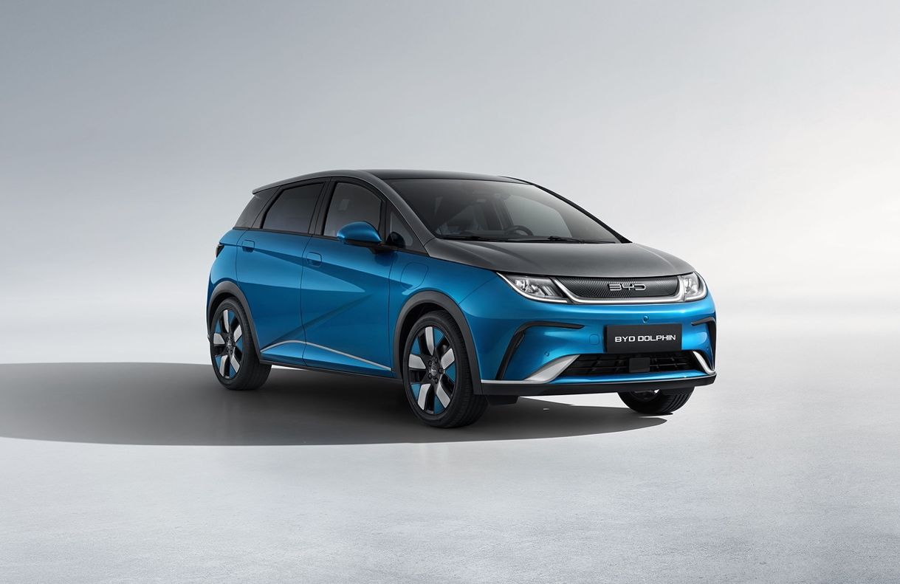
The BYD DOLPHIN design is distinctive from every angle, as with the rest of the vehicle due to its rounded profile and side silhouette resembling the graceful lines of a leaping dolphin. It exudes a sense of fun and agility, while also feeling safe and welcoming.

Spacious and Practical
Based on the BYD DOLPHIN’s new energy attributes, the short front and rear overhangs and long wheelbase give the car a more spacious appearance. Measuring 4,290 mm long and 1,770 mm wide (with wing mirrors unfolded), the BYD DOLPHIN features a 2,700 mm wheelbase optimised for space and comfort. The vehicle height is 1,570 mm.

Ergonomic Seating for Driver and Passenger Comfort
With seating for five occupants, the ergonomically designed sports seats and headrests are made from vegan leather. The heated front seats have a six-way electric adjustment for the driver and a four-way electric adjustment for the front passenger. The rear seats provide generous legroom for passengers, made possible by the e-Platform 3.0. The front seat’s shoulder and back support has been specially optimised, and the side wings are more upright, perfectly fitting the body’s curves for a more comfortable, wraparound ride.

Optimum Storage makes the BYD DOLPHIN Versatile and Practical
The seats can split 60:40 allowing the 345-litre boot to be expanded to 1,310 litres when both seats are folded flat. The BYD DOLPHIN is designed with more than 20 practical and flexible storage spaces for daily travel, and the boot can easily store four standard 20-inch suitcases.

Light and Airy Refined Interior

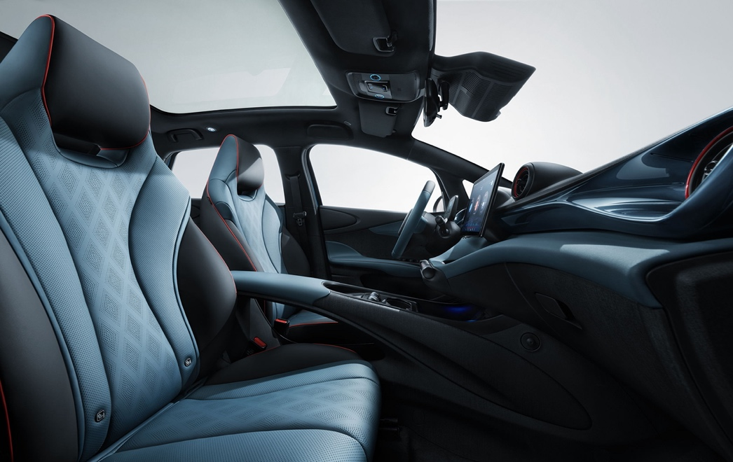
The BYD DOLPHIN range topping variants feature a large panoramic roof made of high-strength acoustic and thermally insulated double-layer grey glazing, with a glass area comparable to that of a D-class luxury car. This provides users with an ultra-wide-angle view, a larger light area, and a more transparent view. It is also equipped with a 97% sunshade to keep you cool on hot summer days.
The stylish interior of the BYD DOLPHIN is designed with smooth, expansive curves to create the illusion that the occupants are wrapped in waves. By placing conventional functions at the driver’s fingertips, the dashboard's simple and refined design provides an innovative interactive experience. Less space is occupied by physical buttons, allowing for extra storage.

Vehicle-To-Load as a Standard to Suit all Lifestyles
The BYD DOLPHIN provides VtoL discharge back technology, which can achieve 3.3kW external discharge, allowing the new energy vehicle to become a mobile power station. This provides convenience for activities such as outdoor picnics and open-air movies, allowing multiple lifestyle applications.

High Spec Safety & Driving Assistance
The BYD DOLPHIN comes standard with an abundance of safety and advanced driver assistance features. All models feature Forward Collision Warning, Autonomous Emergency Braking, Rear Collision Warning, Rear Cross Traffic Alert and Rear Cross Traffic Brake, Lane Departure Prevention and Emergency Lane Keeping Assist.
Adaptive Cruise Control and Intelligent Cruise Control add to the enjoyment of driving. The panoramic camera provides the driver with 360-degree visibility for safe vehicle manoeuvring. In addition, a Blind Spot Detection System, Electronic Stability Control, Traction Control, Hill Decent Control, Automatic Vehicle Hold, and Traffic Sign Recognition with Intelligent Speed Limit Control are included as additional driver aids.

Exceptional Visibility: Cutting-Edge Lighting Technology
Cutting-edge lighting technology also provides a broader beam of light to assist visibility when driving at night, with High Beam Assist, Adaptive Front Headlights and Follow Me Home as a standard.

Dolphin-Inspired Two-Tone Colour Palette brings a Feel of Exclusivity
Inspired by the biological characteristics of the dolphin, the design team gave the BYD DOLPHIN a two-tone body and echoed the colours inside and out to create a sense of exclusivity. The exterior of the BYD DOLPHIN will be available in seven colour combinations.

Details of the BYD DOLPHIN with 44.9 kWh Blade Battery will be announced closer to market entry in Q 1 2024.
BYD DOLPHIN Specification
Dimension (L/W/H) | 4,290/1,770/1,570
Kerb weight (kg) | 1658 (Comfort and Design)
wheelbase(mm) | 2700
Drive type | FWD
Top speed (km/h) | 150 (Active)  ​160 (Boost, Comfort and Design)
Motor power(kW) | 70 (Active)  ​130 (Boost)  ​150 (Comfort and Design)
0-100km/h acceleration time (s) | 7 (Comfort and Design)
Wheel size (inch) | 16 (Active)  ​17 (Boost, Comfort and Design)
Electric range - WLTP Combined (km) | 340 (Active, for reference only)  ​310 (Boost, for reference only)  ​427 (Comfort and Design)
Trunk volume (L) | 345/1,310
Seating capacity (occupants) | 5
Battery type | BYD Blade Battery (LFP)
Rated capacity (kWh) | 44.9 (Active and Boost)  ​60.4 (Comfort and Design)
Charging power | Active and Boost:  ​60kW DC ​ ​  ​7kW AC  ​Comfort and Design:  88kW DC ​ ​  ​11kW AC (3 phase)
DC charging time (30-80%, min) | 28 (Active and Boost)  ​29 (Comfort and Design)
Heat Pump | Standard
V2L function | Standard

Media gallery

BYD DOLPHIN - Atlantis Grey :
https://press.bydauto.be/media/album/21106

BYD DOLPHIN - Creamy White :
https://press.bydauto.be/media/album/21107

BYD DOLPHIN - Interior and exterior :
https://press.bydauto.be/media/album/21869

ENQUIRIES
Inchcape plc BeLux

Muriel GILBERT
Head of PR & Events, BYD BeLux
- muriel.gilbert@inchcape.be
- bydauto.be

